Name _______________________________________
Teacher______________________________________
Period ____________ Total Points ________

Make sure you are signed into your Gizmos account given to you by your teacher. You can use screenshots and text to fill in your answers for the Scavenger Hunt!
Points | TASK | Answer (can be text, screenshots from Gizmos, or combos of both)
Unit One
MGSE9-12.N.RN.2 Rewrite expressions involving radicals
Use the Simplifying Radical Expressions Gizmo to simplify the THIRD example in the activity. Show all correct steps by using the screenshot feature.
MGSE9-12.N.Q.1b. Convert units and rates using dimensional analysis
Explore the Unit Conversions Gizmo (choose Mixed Units) and answer two of the following:
- How many feet long is Shaquille O’Neal’s foot?
- How many milliliters of milk are in a 1-gallon jug?
- A car travels 64.2 miles in 51.8 minutes. What is the average speed of the car in meters per second?
- June has 30 days. How many minutes are in June?
MGSE9-12.A.APR.1 Add, subtract, and multiply polynomials
Use the Addition of Polynomials Gizmo to model the addition and solution of the problem below.
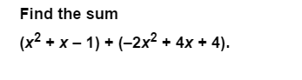
Unit Two
MGSE9-12.A.CED.4 Rearrange formulas to highlight a quantity of interest using the same reasoning as in solving equations.
Utilize the Solving Formulas for Any Variable Gizmo and solve the formula as indicated below.
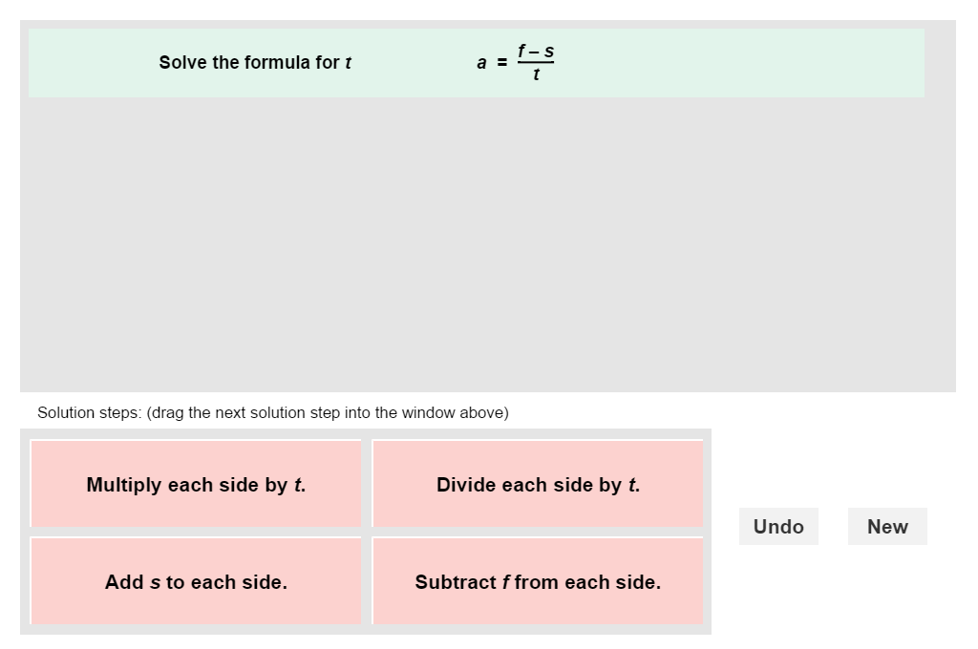
MGSE9-12.A.REI.1 Using algebraic properties and the properties of real numbers, justify the steps of a simple, one-solution equation.
Use the Solving Two Step Equations Gizmos to answer #2 in the Student Exploration Sheet.
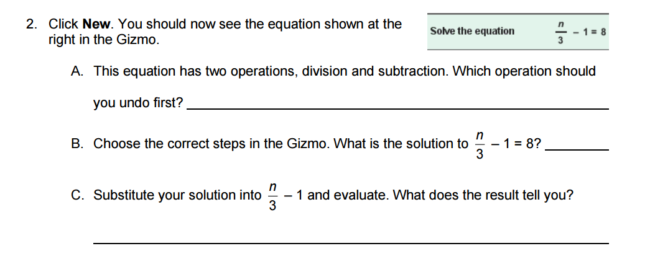
MGSE9-12.A.REI.3 Solve linear equations and inequalities in one variable
Use the Solving Inequalities in One Variable Gizmo to solve and verify the inequality shown below.
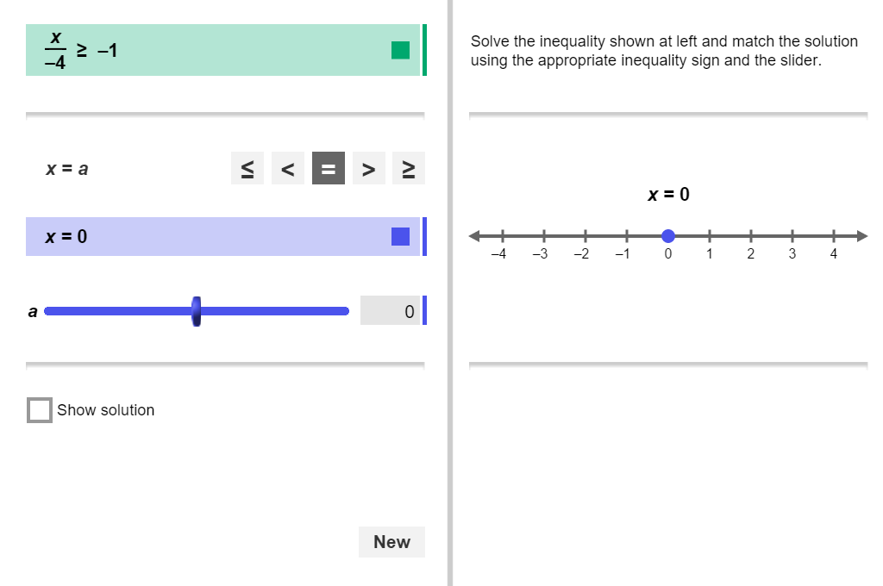
MGSE9-12.A.REI.5 Show and explain why the elimination method works to solve a system of two-variable equations.
MGSE9-12.A.REI.6 Solve systems of linear equations exactly and approximately (e.g., with graphs), focusing on pairs of linear equations in two variables.
Explore the Solving Linear Systems (Linear Form) Gizmo and use it to solve the system below using Graphing, Elimination, and Substitution. Screenshot all solutions from the Gizmo. Then, explain the elimination solution in your own words.
2x + 3y = 5
2x – y = 1
MGSE9-12.A.REI.12 Graph the solution set to a linear inequality in two variables.
Use the Linear Inequalities in Two Variables Gizmo to create an inequality that has a slope of 4, a y-intercept of -1 and uses the symbol greater than or equal to. Screenshot your solution.
MGSE9-12.F.BF.2 Write arithmetic and geometric sequences recursively and explicitly, use them to model situations, and translate between the two forms. Connect arithmetic sequences to linear functions.
Use the Arithmetic Sequences Gizmo to find the first four terms of the arithmetic sequence when a₁ = 3 and d = 2. Graph the sequence and list the recursive and explicit formulas.

MGSE9-12.F.IF.1 Understand that a function from one set (the input, called the domain) to another set (the output, called the range) assigns to each element of the domain exactly one element of the range.
Use the Linear Functions Gizmo to complete the following:
Use the mapping diagram to plot (1, 3), (3, 7), and (4, 9). Show your work through screenshot.
Why do these points determine a function?
Drag one of the points to a different location so that the relation no longer represents a function. What are the new coordinates of the point? Screenshot your work.
Explain why this set of points is not a function now.

MGSE9-12.F.IF.4 Using tables, graphs, and verbal descriptions, interpret the key characteristics of a function which models the relationship between two quantities. Sketch a graph showing key features including: intercepts; interval where the function is increasing, decreasing, positive, or negative; relative maximums and minimums; symmetries; end behavior; and periodicity.
Create the equation below using the Graphs of Polynomial Functions Gizmo. Screenshot the graph and identify the characteristics outlined in the standard.

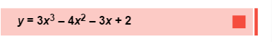
MGSE9-12.F.IF.6 Calculate and interpret the average rate of change of a function (presented symbolically or as a table) over a specified interval. Estimate the rate of change from a graph.
Use the Distance Time Gizmo to create a scenario in which the runner has an average rate of change of 6 feet per second. Screenshot your graph. In your scenario, where will the runner be at 3 seconds? How would this information look in a table?
Unit Three
MGSE9-12.A.SSE.2 Use the structure of an expression to rewrite it in different equivalent forms (thus recognizing it as a difference of squares that can be factored).
Use the Factoring Special Products Gizmo to review and justify your solution to the following: What is the appropriate next step in the problem? Justify. Choose one of the incorrect next steps and explain why it is incorrect.
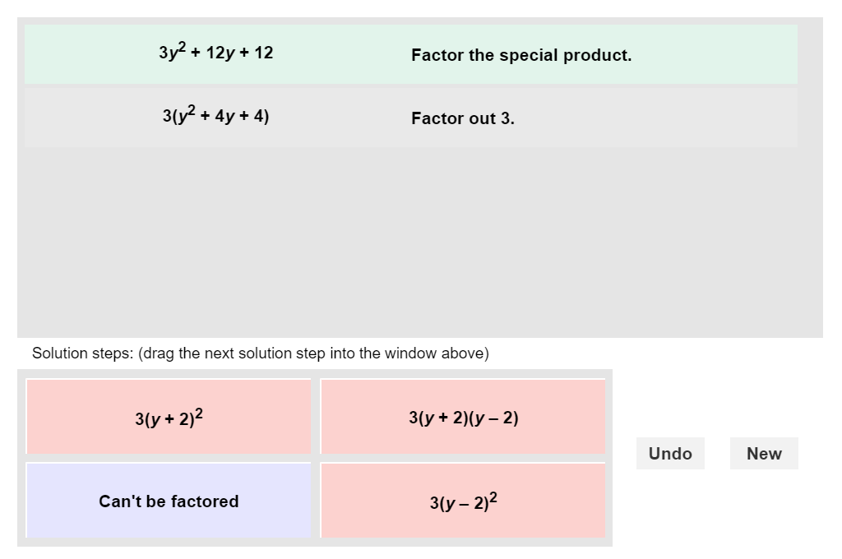
MGSE9-12.A.SSE.3a Factor any quadratic expression to reveal the zeros of the function defined by the expression.
Use the Quadratics in Factored Form Gizmo to show in algebraic, analytic, and graphing format a quadratic whose zeroes are -2 and 5. Also, list the polynomial version of your function.

MGSE9-12.A.CED.1 Create equations and inequalities in one variable and use them to solve problems. Include equations arising from quadratic functions (integer inputs only).
Consider the graph of y < –3x² – x + 1.
What is the equation of the boundary of the inequality?
Will the boundary be solid or dashed?
Which side of the boundary do you think will be shaded? List your test points.
Check your answer using the Quadratic Inequalities Gizmo.

MGSE9-12.A.REI.4b Solve quadratic equations by inspection (e.g., for x² = 49), taking square roots, factoring, completing the square, and the quadratic formula, as appropriate to the initial form of the equation (limit to real number solutions).
Use the Roots of a Quadratic Gizmo to show the solution of f(x) = x² + 4x – 5 using graphing, factoring, and the quadratic formula.

MGSE9-12.F.BF.3 Identify the effect on the graph of replacing f(x) by f(x) + k, k f(x), f(kx), and f(x + k) for specific values of k (both positive and negative); find the value of k given the graphs.
Use the Translating and Scaling Functions Gizmo to investigate changes k will make on the quadratic function. Then, graph all of the following graphs on the same grid. Screenshot your results.
With f(x) set as the quadratic function graph, find f(x) – 3, 2*f(x), f(2x), -2*f(x), and f(x – 3).
Unit Four
MGSE9-12.A.CED.2 Create exponential equations in two or more variables to represent relationships between quantities; graph equations on coordinate axes with labels and scales.
MGSE9-12.F.IF.7e Graph exponential functions, showing intercepts and end behavior
Using the Introduction to Exponential Functions Gizmo, answer the following and show proof.
Consider the function y = 5^x . (Do not use the Gizmo yet.)
List six points that lie on the graph of y = 5^x . (–3, _) (–2, _) (–1, _) (0, _) (1, _) (2, _)
In general, what happens to the y-values as the x-value increase by 1? By 2?
What happens to the y-values as the x-value decreases by 1? By 2?
How do you think the y-values change as x increases from 6 to 9? Explain.
In the Gizmo, select Show additional exponential function.
Graph the functions y = 5^x and y = (1/5)^x . (Hint: In the Gizmo, you will need to use the decimal version of 1/5.) Screenshot the graph.
How do the graphs differ? How are the graphs similar?
MGSE9-12.F.BF.2 Write geometric sequences recursively and explicitly, use them to model situations, and translate between the two forms. Connect geometric sequences to exponential functions.
Consider the geometric sequence –0.5, –1, –2, –4, …
Express this sequence both explicitly and recursively.
What is the 10th term? Check your answer in the Geometric Sequences Gizmo.
Which formula works better for finding terms that are later in the sequence, like a20? Explain.
Unit Five
MGSE9-12.F.LE.1a Show that linear functions grow by equal differences over equal intervals and that exponential functions grow by equal factors over equal intervals. (This can be shown by algebraic proof, with a table showing differences, or by calculating average rates of change over equal intervals).
Jacob currently has a summer job earning $8 per hour. Each summer he is guaranteed a 5% increase over the previous summer.

Does this scenario represent a linear or exponential function? Provide evidence and reasoning for your answer.
OR
After knee surgery, your trainer tells you to return to your jogging program slowly. He suggests jogging for 12 minutes each day for the first week. Each week thereafter, he suggests that you increase that time by 6 minutes per day.

How many weeks will it be before you are up to jogging 60 minutes per day? Does this scenario represent a linear or exponential function? Provide evidence and reasoning for your answer.

Use any of the Gizmos from sequences, linear functions, and/or exponential functions to verify your answers.

MGSE9-12.F.LE.1c Recognize situations in which a quantity grows or decays by a constant percent rate per unit interval relative to another.
Jason buys a car for $24,000. The car depreciates (loses value) at a rate of 18% each year.
What function models the value of the car after t years?
What is the value of the car after 6 years? (Use a calculator.)
Check your answers in the Exponential Growth and Decay Gizmo. (Use C = 24.) Fix any mistakes above, if needed.
About when will the car be worth half its initial value? (Use the probe.)
Unit Six
MGSE9-12.S.ID.1 Represent data with plots on the real number line (dot plots, histograms, and box plots).
Complete the Reaction Time Gizmo – Activity B or Activity C. Use the Student Exploration Sheet in the word format or cut and paste your answers.
MGSE9-12.S.ID.6 Represent data on two quantitative variables on a scatter plot, and describe how the variables are related.
Complete the Trends in Scatter Plots Gizmo – Activity B. Use the Student Exploration Sheet in the word format or cut and paste your answers.
MGSE9-12.S.ID.7 Interpret the slope (rate of change) and the intercept (constant term) of a linear model in the context of the data.
Using the screenshot from the Distance Time Gizmo below, write the slope story of the runner – discuss his direction and create reasons for his path. Use the Gizmo to review the concept of rate of change.
